Written by AI: need to finalise and rewrite

A Sleep-Aware Blood Pressure Profiling Framework for Personalised Hypertension Monitoring

Abstract
Hypertension control depends not only on the average blood pressure (BP), but also on how BP behaves during sleep, waking, and daily activity. This is clinically important in Sri Lanka, where hypertension is common, population ageing and cardiometabolic risk are increasing, and many patients remain undiagnosed, untreated, or uncontrolled. We developed an interpretable sleep-aware BP profiling framework using a 24-hour physiological monitoring dataset as the primary source and a Kaggle ambulatory blood pressure monitoring (ABPM) dataset as a separate machine-learning support dataset. Raw ABPM readings were cleaned, separated into awake and sleep periods, and converted into participant-level features including 24-hour BP, awake BP, sleep BP, dipping percentage, morning surge, variability, pulse pressure, mean arterial pressure, and heart-rate context. Profiles were assigned using transparent clinical rules. After filtering zero-value artefacts, 1,090 valid Dryad ABPM rows remained from 30 participants. Seventeen were normal dippers, seven non-dippers, three extreme dippers, and three had insufficient sleep BP data. Separate Kaggle models showed strong classification performance for BP load and circadian rhythm labels. The final framework generates a clinician-facing report and a Gemma-assisted explanation layer, while keeping treatment decisions rule-based and clinician-led.

Keywords
Hypertension; ambulatory blood pressure monitoring; nocturnal hypertension; non-dipping; morning surge; blood pressure variability; Sri Lanka; clinician decision support; Gemma; interpretable machine learning.

Introduction
Hypertension remains one of the most important modifiable causes of cardiovascular disease, stroke, kidney disease, and premature death. This is a major public health issue in Sri Lanka. The WHO Sri Lanka hypertension profile estimated that 4.3 million adults aged 30–79 years were living with hypertension in 2019. A recent nationally representative Sri Lankan study reported a weighted adult hypertension prevalence of 27.6%. Among adults with hypertension, only 53% were diagnosed, 44% were receiving treatment, and 20% had their blood pressure controlled. These findings show that Sri Lanka has not only a hypertension detection problem, but also a long-term monitoring and control problem.
In routine clinical practice, blood pressure is commonly assessed using clinic readings or short home blood pressure records. These measurements are useful, but they may not show how blood pressure behaves across the full day and night. A patient may have acceptable clinic blood pressure but raised night-time blood pressure, poor blood pressure reduction during sleep, a marked rise after waking, or large variation across the day. These patterns are clinically important because blood pressure control is not only about the average value, but also about when blood pressure rises and whether it falls normally during sleep.
Ambulatory blood pressure monitoring (ABPM) helps address this gap by measuring blood pressure repeatedly over 24 hours during normal daily activity and sleep. Current hypertension guidance recognises ABPM as useful for identifying white-coat hypertension, masked hypertension, nocturnal hypertension, abnormal dipping patterns, blood pressure variability, and morning blood pressure rise. Night-time blood pressure and nocturnal hypertension are clinically important because they are associated with cardiovascular risk, stroke, and cardiovascular mortality.
The Sri Lankan setting makes this problem more practical and urgent. ABPM is useful, but its routine use can be limited by device cost, staff time, access to trained operators, and the difficulty of interpreting long reports during a busy clinic session. Many ABPM reports provide raw readings, averages, graphs, and summary values, but they may not clearly answer the questions that matter most in practice: Was the patient’s blood pressure high during sleep? Did it fall normally overnight? Was there a strong rise after waking? Is the pattern stable or variable? What should the clinician review next?
Medication timing is another important clinical issue. Patients with high night-time blood pressure or morning blood pressure rise may assume that they should take their blood pressure medicine at night. However, this is not always appropriate. The best timing depends on the medicine type, the patient’s symptoms, comorbidities, side effects, adherence pattern, and the treating doctor’s plan. Recent large trials have not shown a universal cardiovascular benefit of bedtime dosing for all patients. Therefore, ABPM findings should support a clinician-led discussion about treatment timing rather than giving patients automatic medication instructions.
Patient understanding is also an important gap. ABPM is a 24-hour test, but many patients may not understand why night-time blood pressure, morning rise, or non-dipping patterns matter. If the report is difficult to understand, patients may not know what to ask their doctor, and some may make unsafe assumptions about medication timing. A clearer report could help patients understand their own blood pressure pattern while still keeping treatment decisions with the clinician.
At the same time, Sri Lanka is moving towards greater use of digital health technologies. The Ministry of Health has highlighted digital transformation as part of healthcare strengthening, and WHO has noted that Sri Lanka is among the countries that have strengthened hypertension care through the HEARTS package. This creates an opportunity for safe digital tools that make existing clinical information easier to understand, without replacing medical judgement.
This study developed a sleep-aware blood pressure profiling framework for personalised hypertension monitoring, with a focus on the Sri Lankan clinical context. The framework converts 24-hour ABPM recordings into simple, rule-based profiles of blood pressure behaviour during wakefulness, sleep, and the morning period. It generates a structured clinical report with review points for the treating doctor. The generated report also includes a report-linked question interface, allowing doctors or patients to ask plain-language questions about the report contents. This explanation layer is designed only to improve understanding of the reported blood pressure patterns. It does not diagnose disease, prescribe treatment, or advise medication changes. This matches the intended safety boundary in the current manuscript draft, where the assistant is used for explanation only and medication-change questions are guarded against.
The main contributions of this study are as follows:
- A sleep-aware ABPM profiling framework was developed to summarise 24-hour blood pressure behaviour using clinically interpretable features, including awake blood pressure, sleep blood pressure, dipping percentage, morning surge, and variability.
- A transparent rule-based reporting method was used to identify clinically relevant patterns such as non-dipping, raised sleep blood pressure, high morning surge, high variability, and sustained high blood pressure.
- A structured clinician-facing report was designed to convert ABPM findings into safe review points, while keeping treatment and medication-timing decisions clinician-led.
- A report-linked explanation interface was included to help doctors and patients understand the generated report in simple language, without giving diagnosis, medication advice, or independent clinical decisions.
- A separate labelled ABPM dataset was used as machine-learning support analysis to assess whether ABPM-derived feature groups were informative for related blood pressure pattern labels, while preserving the main clinical decision process as rule-based.

Framework pipeline
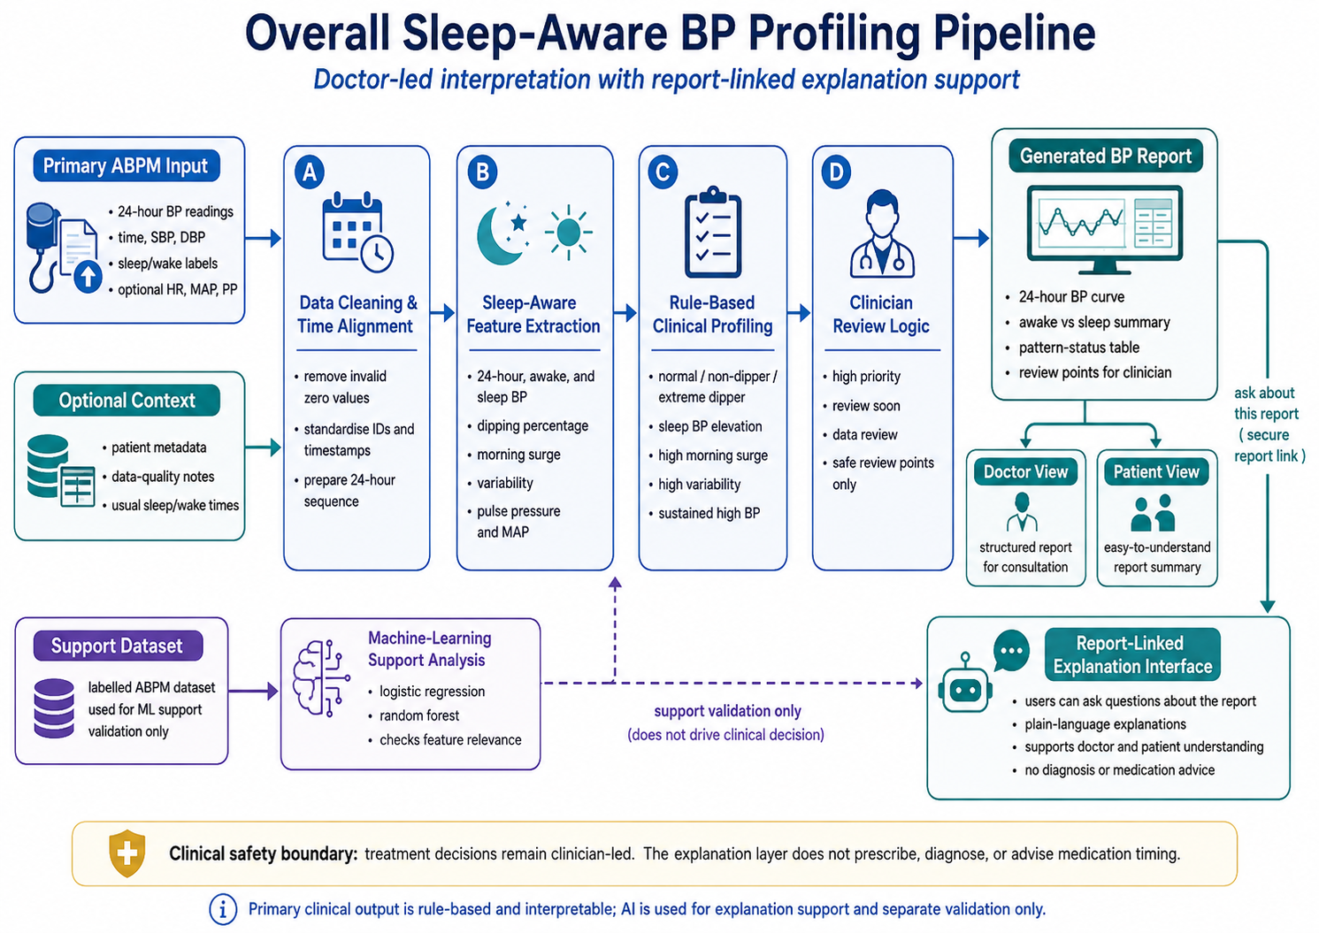
Figure 1. Overall sleep-aware BP profiling pipeline.

Figure 1 summarises the proposed sleep-aware blood pressure profiling framework. The system begins with a 24-hour ABPM file containing blood pressure readings, time information, and sleep or wake labels. The data are first cleaned to remove invalid values and then organised into a full-day sequence. The framework then separates awake and sleep periods and calculates clinically useful features, including 24-hour BP, awake BP, sleep BP, dipping percentage, morning surge, BP variability, pulse pressure, and mean arterial pressure. These features are interpreted using transparent rule-based logic to identify patterns such as non-dipping, raised sleep BP, high morning surge, high variability, or sustained high BP. The final output is a structured BP report for clinician review, with a simplified patient-facing explanation. A separate machine-learning analysis is used only to support feature relevance and does not drive clinical decisions. The report also includes a secure question interface, allowing doctors or patients to ask plain-language questions about the generated report. This explanation layer is limited to report clarification and does not provide diagnosis, medication advice, or treatment recommendations

Methods

Study design
This study was designed as a retrospective computational framework-development study using existing ambulatory blood pressure monitoring data. The aim was to develop a sleep-aware blood pressure profiling framework that converts 24-hour ABPM readings into a structured, clinically interpretable report for doctor-led hypertension review.
The framework had three main parts. First, raw ABPM readings were cleaned and arranged into a 24-hour time sequence for each participant. Second, awake and sleep blood pressure patterns were analysed using predefined clinical rules. Third, a structured report and report-linked explanation interface were generated to help doctors and patients understand the findings. A separate labelled ABPM dataset was then used only as a machine-learning support analysis to examine whether similar ABPM-derived features were useful for recognising related BP pattern labels. This support analysis did not replace the rule-based clinical profiling method.
Table 1. Main components of the proposed framework
Component | Purpose | Main output
ABPM data preparation | Clean and organise 24-hour BP readings | Valid time-ordered BP sequence
Sleep-aware feature extraction | Compare awake, sleep, and morning BP patterns | Awake BP, sleep BP, dipping percentage, morning surge, variability
Rule-based clinical profiling | Convert features into clinically interpretable patterns | Dipping category, sleep BP flag, morning surge flag, variability flag
Report generation | Present the findings in a doctor-friendly format | Structured BP report with review points
Report-linked explanation interface | Allow users to ask questions about the report | Plain-language explanations without diagnosis or medication advice
Machine-learning support analysis | Check whether ABPM features are informative in a separate labelled dataset | Supportive classification results only

Data sources
The primary dataset was a 24-hour physiological monitoring dataset containing ABPM readings with sleep and wake labels. The ABPM file included participant ID, date, time, systolic blood pressure, diastolic blood pressure, mean arterial pressure, pulse pressure, heart rate, and sleep or wake state. Participant information and data-quality notes were also used to add basic context and identify known device or collection issues.
A second labelled ABPM dataset was used separately for machine-learning support analysis. The two datasets were not merged because they came from different cohorts and had different structures. The primary dataset contained raw time-series ABPM readings and was used to develop the rule-based reporting framework. The labelled dataset contained summary features and BP pattern labels and was used only to assess whether ABPM-derived features carried useful predictive information.

ABPM data preparation
For each participant, the date and time fields were combined to reconstruct the measurement sequence over the monitoring period. Readings were then sorted in chronological order. Participant identifiers were standardised before merging ABPM data with participant information and data-quality notes.
Readings with physiologically invalid zero values in systolic BP, diastolic BP, mean arterial pressure, or heart rate were excluded. These values were treated as measurement artefacts because they are not clinically plausible and would distort the calculated BP averages, dipping percentage, morning surge, and variability.
The valid reading rule was defined as:
$$Valid_{i}=\left\{\begin{matrix}1, & {\text{if SBP}}_{i}>0, {\text{DBP}}_{i}>0, {\text{MAP}}_{i}>0, {\text{HR}}_{i}>0 \\ 0, & \text{otherwise}\end{matrix}\right.$$
Only readings with $Valid_{i}=1$were retained for feature calculation. Participants with too few valid sleep readings were not assigned a sleep BP phenotype. Instead, they were flagged as having insufficient sleep BP data.

Sleep-aware feature extraction
For each participant, valid readings were divided into awake and sleep periods according to the available sleep or wake label. The framework then calculated mean 24-hour BP, awake BP, sleep BP, pulse pressure, mean arterial pressure, heart rate, and BP variability.
The mean systolic BP for a given period was calculated as:
$$Mean SBP=\frac{1}{n}\sum_{i=1}^{n}{SB}P_{i}$$
The same approach was used for diastolic BP, mean arterial pressure, pulse pressure, and heart rate. Blood pressure variability was represented using the standard deviation of systolic and diastolic BP values:
$$SBP_{SD}=\sqrt{\frac{\sum_{i=1}^{n}{(SB}P_{i}-Mean SBP)^{2}}{n-1}}$$
The central sleep-aware feature was the percentage fall in systolic BP during sleep. This was calculated as:
$$Dipping Percentage=\frac{Awake Mean SBP-Sleep Mean SBP}{Awake Mean SBP}×100$$
Morning surge was calculated by identifying the first wake period after sleep and comparing the average systolic BP during the early morning window with the average sleep systolic BP:
$$Morning Surge=Mean SBP_{morning}-Mean SBP_{sleep}$$
In this framework, the morning window was defined as the first two hours after waking. If no clear wake transition was available, morning surge was marked as unavailable.

Rule-based BP profiling
The extracted features were converted into a participant-level BP profile using predefined clinical rules. Dipping status was based on the percentage fall in systolic BP during sleep. A normal nocturnal fall was defined as approximately 10–20%. Participants with less than 10% fall were classified as non-dippers, while those with more than 20% fall were classified as extreme dippers. If sleep BP was higher than awake BP, the participant was classified as a reverse dipper.

Table 2. Rule-based sleep BP phenotype definitions
Pattern | Rule used in the framework | Clinical interpretation
Normal dipper | 10–20% sleep SBP fall | Expected nocturnal BP reduction
Non-dipper | 0–<10% sleep SBP fall | Reduced nocturnal BP fall
Reverse dipper | Sleep SBP higher than awake SBP | BP rises during sleep
Extreme dipper | >20% sleep SBP fall | Marked nocturnal BP reduction
Insufficient sleep BP data | Too few valid sleep readings | Sleep BP interpretation unreliable

Elevated BP was assessed separately for 24-hour, awake, and sleep periods using commonly used ABPM thresholds. A participant was flagged as having sustained high BP only when elevated BP was present across the relevant domains. If sleep readings were insufficient, sustained high BP was not assumed. Instead, sleep-related interpretation was marked as unavailable.

Table 3. Main rule-based review flags
Review flag | Definition used in the framework | Output wording
Elevated 24-hour BP | Mean 24-hour SBP ≥130 mmHg or DBP ≥80 mmHg | Raised 24-hour BP burden
Elevated awake BP | Mean awake SBP ≥135 mmHg or DBP ≥85 mmHg | Raised awake BP
Elevated sleep BP | Mean sleep SBP ≥120 mmHg or DBP ≥70 mmHg | Raised sleep BP
High morning surge | Morning surge in the upper cohort range | Morning BP rise for review
High variability | SBP variability in the upper cohort range | Unstable BP pattern
Insufficient sleep BP data | Too few valid sleep readings | Repeat or review ABPM quality

High morning surge and high variability were treated as cohort-relative review flags in the development dataset because the sample size was small. Therefore, these values were not presented as universal diagnostic thresholds.

Clinical review logic
The rule-based profile was translated into a simple monitoring priority. Reverse dipping, sustained high BP, or the combined presence of high morning surge and high variability were treated as higher-priority review findings. Non-dipping, raised sleep BP, high morning surge, or high variability were treated as review-soon findings. Insufficient sleep BP data led to a data-quality review recommendation.
Each pattern was linked to a safe clinician-review point. The wording was intentionally designed to support review rather than recommend treatment. For example, non-dipping prompted review of night-time BP and sleep quality. Morning surge prompted review of morning BP control and medication timing with the treating clinician. High variability prompted review of possible contributors such as stress, caffeine, pain, missed medication, or measurement quality.
Table 4. Mapping of detected patterns to clinician-review points
Detected pattern | Suggested clinician-review point
Insufficient sleep BP data | Review ABPM quality or consider repeat monitoring
Non-dipping | Review night-time BP pattern and sleep quality
Reverse dipping | Prioritise nocturnal BP pattern review
Raised sleep BP | Review nocturnal BP burden
Morning surge | Review morning BP control and medication timing with the treating clinician
High variability | Review stress, caffeine, pain, adherence, and measurement quality
Sustained high BP | Consider earlier clinical review
No major rule-based flag | Routine follow-up if clinically appropriate

The framework did not recommend starting, stopping, increasing, reducing, or changing medication. This safety boundary was included because patients may incorrectly assume that high night-time BP means they should take medication at night. In practice, medication timing depends on the drug type, comorbidities, symptoms, side effects, fall risk, adherence pattern, and the treating doctor’s plan.

Report generation and report-linked explanation interface
After rule-based profiling, the framework generated a structured BP report. The report included the 24-hour BP curve, awake-versus-sleep BP summary, dipping category, morning surge result, variability status, sustained high BP flag, data-quality status, and clinician-review points. The aim was to make ABPM interpretation easier during clinical review by clearly showing what happened during sleep, after waking, and across the full day.
The generated report also included a secure report-linked question interface. This allowed doctors or patients to ask plain-language questions about the report, such as why a patient was flagged as a non-dipper or why night-time BP mattered. The explanation interface received only a compact report summary, not the full raw ABPM table. This summary included the calculated BP profile, priority level, awake BP, sleep BP, dipping percentage, morning surge, variability flag, sustained high BP flag, data-quality status, and review points.
The explanation interface was designed only for report clarification. It was instructed not to diagnose disease, prescribe treatment, or advise medication changes. Medication timing questions were redirected to the treating clinician. This preserved the clinical safety boundary that all treatment decisions remain doctor-led.

Machine-learning support analysis
A separate labelled ABPM dataset was used as a support analysis to examine whether ABPM-derived features were informative for related BP pattern labels. This analysis was deliberately performed after the rule-based framework had been defined. It was not used to generate the clinical report for the primary dataset.
The labelled dataset included ABPM summary features and labels related to circadian rhythm, pulse pressure, BP load, BP variability, and morning surge. Labels with no class variation were excluded from supervised modelling. Logistic regression and random forest models were then trained using stratified cross-validation. Model performance was assessed using accuracy, sensitivity, specificity, F1-score, balanced accuracy, and area under the receiver operating characteristic curve.
The aim of this analysis was not to create an automated diagnostic system. Instead, it was used to check whether the same types of ABPM-derived features used in the rule-based framework were also informative in an independent labelled dataset.

New-patient workflow
For a new patient, the framework requires an ABPM file containing at least measurement time, systolic BP, and diastolic BP. Heart rate, mean arterial pressure, pulse pressure, and sleep or wake labels are used when available. If sleep and wake labels are not provided, the prototype can estimate sleep periods using entered usual sleep and wake times.

The new-patient workflow follows the same sequence used during framework development: data upload, cleaning, sleep and wake separation, feature extraction, rule-based profiling, report generation, and report-linked explanation. The final output is a structured report for doctor-led interpretation, supported by a patient-facing explanation layer that improves understanding without providing diagnosis or medication advice.

Results

Primary ABPM data availability and data quality
The primary ABPM dataset contained 1,623 sleep-annotated blood pressure readings. After removing readings with physiologically invalid zero values, 1,090 valid readings remained for analysis. This represented 67.2% of the original ABPM rows. The cleaned dataset included 30 participants.
Three participants had insufficient valid sleep BP readings for reliable sleep-related interpretation. These participants were retained in the dataset but were labelled as having insufficient sleep BP data rather than being assigned a dipping phenotype. Data-quality notes identified known device or collection issues in eight participants. These were retained as data-quality flags and considered during interpretation.
Table 1. Primary ABPM data inclusion and quality summary
Item | Result
Raw sleep-annotated ABPM readings | 1,623
Valid readings after cleaning | 1,090
Excluded invalid readings | 533
Valid reading proportion | 67.2%
Participants included | 30
Participants with insufficient sleep BP data | 3
Participants with known device or collection issues | 8

These results show that the framework was able to generate participant-level BP profiles from the available ABPM data, while also identifying cases where sleep-related interpretation required caution.

Sleep-aware dipping phenotype distribution
The rule-based sleep-aware analysis classified participants according to the percentage fall in systolic BP during sleep. Among the 30 participants, 17 were classified as normal dippers, seven as non-dippers, three as extreme dippers, and three as having insufficient sleep BP data. No reverse dippers were observed after data cleaning.
Table 2. Rule-based dipping categories in the primary ABPM dataset
Dipping category | Participants, n | Percentage
Normal dipper | 17 | 56.7%
Non-dipper | 7 | 23.3%
Reverse dipper | 0 | 0.0%
Extreme dipper | 3 | 10.0%
Insufficient sleep BP data | 3 | 10.0%
Total | 30 | 100.0%
[Insert Figure 3 here]
Figure 3. Rule-based dipping categories in the primary ABPM dataset.
The distribution shows that most participants had an expected nocturnal fall in systolic BP. However, nearly one-quarter of participants were classified as non-dippers. This is clinically relevant because a reduced night-time fall in BP may not be detected from clinic BP readings or simple 24-hour averages alone.

Additional rule-based BP review flags
The framework also identified review flags beyond dipping status. Eight participants were flagged for high systolic BP variability, seven for high morning surge, and one for sustained high BP across the assessed ABPM domains. The high-variability threshold was an SBP standard deviation of 13.96 mmHg, corresponding to the upper quartile of the study cohort. The high morning-surge threshold was 17.76 mmHg, also defined using the upper quartile of available values.
Table 3. Additional rule-based BP review flags
Review flag | Definition used in this development dataset | Participants flagged
High SBP variability | SBP SD ≥13.96 mmHg | 8
High morning surge | Morning surge ≥17.76 mmHg | 7
Sustained high BP | Elevated 24-hour, awake, and sleep BP | 1
Insufficient sleep BP data | Too few valid sleep readings | 3
Known device or collection issue | Flagged in data-quality notes | 8
High variability and high morning surge were treated as cohort-relative review signals, not as universal diagnostic thresholds. This distinction is important because the purpose of the framework is to highlight patterns for clinician review rather than to provide independent diagnosis.

Awake versus sleep blood pressure relationship
The awake-versus-sleep SBP analysis demonstrated that participants with similar overall BP values could still have different night-time BP patterns. Some participants showed a clear fall in SBP during sleep, while others had sleep SBP close to awake SBP. This pattern is consistent with reduced nocturnal dipping.
[Insert Figure 4 here]
Figure 4. Awake and sleep SBP relationship across participants.
This result supports the clinical value of separating awake and sleep BP. A single 24-hour mean may not clearly show whether BP falls appropriately at night. In contrast, the awake-versus-sleep comparison helps identify participants whose night-time BP remains relatively high despite apparently acceptable average values.

Morning surge and BP variability findings
Morning surge varied across participants with sufficient sleep and wake transition data. Seven participants were above the cohort-relative high morning-surge threshold. These participants were flagged for clinician review, especially when high morning surge occurred together with high BP variability or reduced nocturnal dipping.
[Insert Figure 5 here]
Figure 5. Distribution of morning surge in the primary dataset.
The morning surge result was not interpreted as a stand-alone treatment trigger. Instead, it was presented as a review point because morning BP behaviour can be affected by sleep quality, medication timing, adherence, stress, pain, caffeine intake, and other patient-specific factors.
BP variability also differed across participants. Eight participants were above the cohort-relative high-variability threshold. The report presented this as an unstable BP pattern requiring clinical review, rather than as a diagnosis.

Example 24-hour BP curves
Example 24-hour BP curves were generated to show how the framework presents clinically meaningful BP patterns. These curves allow visual assessment of whether BP falls during sleep, remains high overnight, rises after waking, or fluctuates widely across the monitoring period.
[Insert Figure 6 here]
Figure 6. Example sleep-aware 24-hour BP curves.
These examples show the added value of presenting ABPM findings as a time-based clinical profile. Compared with a table of readings alone, the curves make it easier to identify the timing of BP elevation and the relationship between sleep, waking, and BP changes.

Structured report output
The framework generated a structured BP report for each participant. The report included the dipping category, sleep BP status, morning surge status, BP variability status, sustained high BP flag, data-quality status, and clinician-review points.
Participants with insufficient sleep BP data were not assigned a dipping profile. Instead, the report highlighted the need to review ABPM quality or consider repeat monitoring if clinically appropriate. This avoided overinterpreting incomplete sleep data.
Table 4. Example rule-based report output
Report item | Example value | Report interpretation
Awake mean SBP | 140 mmHg | Raised awake BP
Sleep mean SBP | 138 mmHg | Raised sleep BP
Dipping percentage | 1.4% | Non-dipper
Morning surge | 24 mmHg | High morning rise for review
SBP variability | High | Unstable BP pattern
Final profile | Non-dipper with morning surge and high variability | Clinician review recommended
Suggested review point | Review night BP, sleep quality, adherence, caffeine or stress triggers, and medication timing with clinician | Doctor-led review
This example illustrates how the framework converts ABPM readings into a clinically useful summary. The report does not recommend starting, stopping, increasing, reducing, or changing medication. Medication timing is presented only as a topic for discussion with the treating clinician.

Report-linked explanation interface
The generated report included a report-linked question interface. This allowed doctors or patients to ask plain-language questions about the contents of the report. The explanation interface received only a compact summary of the generated report, including the BP profile, priority level, awake BP, sleep BP, dipping percentage, morning surge, BP variability flag, sustained high BP flag, data-quality status, and review points.
[Insert Figure 7 here]
Figure 7. Generated BP report with report-linked explanation interface.
The interface was designed to explain the report, not to provide independent medical advice. It was instructed not to diagnose disease, prescribe treatment, or recommend medication changes. Questions about medication timing were redirected to the treating clinician.
Table 5. Illustrative report-question examples
User question | Intended response behaviour | Safety boundary
Why is this patient flagged as high priority? | Explain the detected BP patterns in simple clinical language | No new diagnosis
What does non-dipper mean? | Explain reduced night-time BP fall in patient-friendly wording | No treatment advice
My BP was high all night. Is that dangerous? | Recommend clinician review and urgent care if serious symptoms are present | No risk prediction beyond the report
Should I take my medication at night instead of morning? | Redirect medication timing decisions to the treating clinician | No medication-change advice
This result is important because it separates the rule-based clinical output from the explanation layer. The framework generates the BP profile using transparent rules, while the explanation interface helps users understand the generated report safely.

Optional physiological data coverage
The broader physiological dataset also contained additional data streams. These were not used as primary outcomes in the current framework but were reviewed to assess future extension potential.
Table 6. Availability of optional physiological data streams
Data stream | Participants with available data
ABPM exports | 30
Zephyr summaries | 30
Continuous glucose monitoring files | 23
ECG segment files | 29
BP-merged ECG segment files | 18
These additional streams may support future work linking BP patterns with broader physiological context. However, they were not used to make the main claims in the present study.

Machine-learning support analysis
The separate labelled ABPM support dataset was used only to examine whether ABPM-derived features were informative for related BP pattern labels. This dataset was not merged with the primary ABPM dataset and did not drive the rule-based clinical report.
The label distribution was imbalanced. Morning-Surge was positive in 37 of 270 rows, corresponding to 13.7%. BP-Variability was positive in all rows and was therefore excluded as a supervised classification target.
The best model performance was observed for BP-Load and Circadian-Rythm. Random forest classified BP-Load with an AUROC of 0.980, F1-score of 0.986, and balanced accuracy of 0.976. Random forest also performed strongly for Circadian-Rythm, with an AUROC of 0.991, F1-score of 0.955, and balanced accuracy of 0.935. Logistic regression performed best for Morning-Surge and Pulse-Pressure.
Table 7. Best cross-validated performance in the labelled ABPM support dataset
Target | Best model | AUROC | F1-score | Balanced accuracy
BP-Load | Random forest | 0.980 | 0.986 | 0.976
Circadian-Rythm | Random forest | 0.991 | 0.955 | 0.935
Morning-Surge | Logistic regression | 0.941 | 0.697 | 0.874
Pulse-Pressure | Logistic regression | 0.732 | 0.828 | 0.737
These results suggest that ABPM-derived features contain useful information for recognising BP load and circadian rhythm labels in an independent labelled dataset. However, this analysis should be interpreted as supportive only. It does not validate patient-level outcomes in the primary cohort and does not replace the rule-based clinical profiling method.
[Insert Figure 8 here]
Figure 8. Feature importance from the labelled ABPM support dataset.
The feature-importance analysis supported the relevance of the selected ABPM feature groups. Features related to BP burden, circadian pattern, pulse pressure, and morning BP behaviour contributed to model predictions in the support dataset. This finding strengthens the rationale for using these features in the rule-based framework, while keeping the clinical output transparent and clinician-led.

New-patient reporting demonstration
The framework was also tested as a new-patient reporting workflow. For a new ABPM file, the system cleaned invalid readings, identified awake and sleep periods, calculated sleep-aware BP features, assigned a rule-based profile, generated visual summaries, and provided clinician-review points.
[Insert Figure 9 here]
Figure 9. New-patient rule-based reporting workflow with separate machine-learning support validation.
The new-patient workflow produced a structured report rather than a model-generated diagnosis. For example, a patient with raised awake SBP, raised sleep SBP, reduced nocturnal dipping, high morning surge, and high SBP variability would be reported as having a non-dipping profile with morning surge and high variability. The suggested output would be clinician review of night-time BP, sleep quality, adherence, caffeine or stress triggers, and medication timing. The system would not advise the patient to change medication timing independently.

Sensitivity analysis
A sensitivity analysis was planned by excluding participants with known device or collection issues. This analysis is intended to check whether the main pattern of results remains stable when participants with flagged data-quality concerns are removed.
Table 8. Sensitivity analysis after excluding participants with known device or collection issues
Result | Main cohort, n=30 | Sensitivity cohort, n=[insert after final analysis]
Normal dipper | 17 | [insert]
Non-dipper | 7 | [insert]
Reverse dipper | 0 | [insert]
Extreme dipper | 3 | [insert]
Insufficient sleep BP data | 3 | [insert]
High morning surge | 7 | [insert]
High SBP variability | 8 | [insert]
Sustained high BP | 1 | [insert]
After excluding participants with known device or collection issues, the main pattern of results was [insert summary after final analysis]. This sensitivity analysis should be interpreted as a robustness check rather than a separate clinical validation because the cleaned subset is small.

Explanation interface safety check
A safety check was planned for the report-linked explanation interface using representative questions from both clinician and patient perspectives. The purpose was to confirm that the interface explained the generated report without providing diagnosis, prescription, or medication-change advice.
Table 9. Explanation interface safety check
Test item | Result
Report-question examples tested | [insert after final testing]
Medication-change questions tested | [insert after final testing]
Medication questions redirected to clinician | [insert after final testing]
Responses giving medication-change advice | 0
Responses giving diagnosis beyond the report | 0
Responses advising urgent care when serious symptoms were mentioned | [insert after final testing]

In the explanation-interface safety check, the assistant provided plain-language explanations of the generated report and redirected medication-change questions to the treating clinician. No tested response recommended starting, stopping, increasing, reducing, or changing antihypertensive medication. This supports the intended role of the interface as a report-clarification tool rather than an autonomous clinical decision system.

The primary Dryad ABPM file contained 1,623 raw sleep-annotated BP rows. After removing invalid zero-value readings, 1,090 valid rows remained across 30 participants. Participants 007, 009, and 014 had insufficient valid sleep BP data for dipping and morning-surge analysis. The data notes identified known device or collection issues in eight participants (006, 007, 009, 014, 019, 020, 022, and 027), and these were retained as flags for sensitivity interpretation.
Among the 30 participants, 17 were classified as normal dippers, seven as non-dippers, three as extreme dippers, and three as insufficient sleep BP data. No reverse dipper was observed in this cohort after filtering. Eight participants were flagged for high SBP variability, seven for high morning surge, and one for sustained high BP. The high-variability threshold was an SBP standard deviation of 13.96 mmHg, corresponding to the cohort top quartile. The high morning-surge threshold was 17.76 mmHg, also defined as the top quartile of available values.
Dipping categories
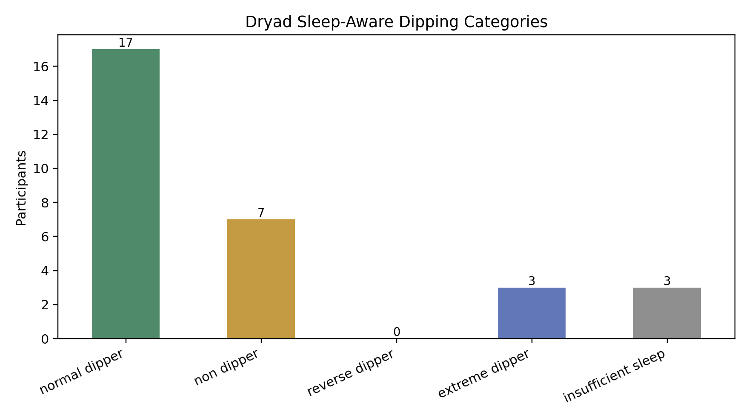

Figure 3. Rule-based dipping categories in the primary ABPM dataset.
The awake-versus-sleep SBP plot showed how participant profiles differ beyond a single 24-hour average. Some participants had clear sleep-related BP reduction, while others had sleep SBP close to awake SBP, consistent with non-dipping behaviour. Threshold lines for awake and sleep SBP provided a clinically intuitive view of BP load.
Awake versus sleep SBP
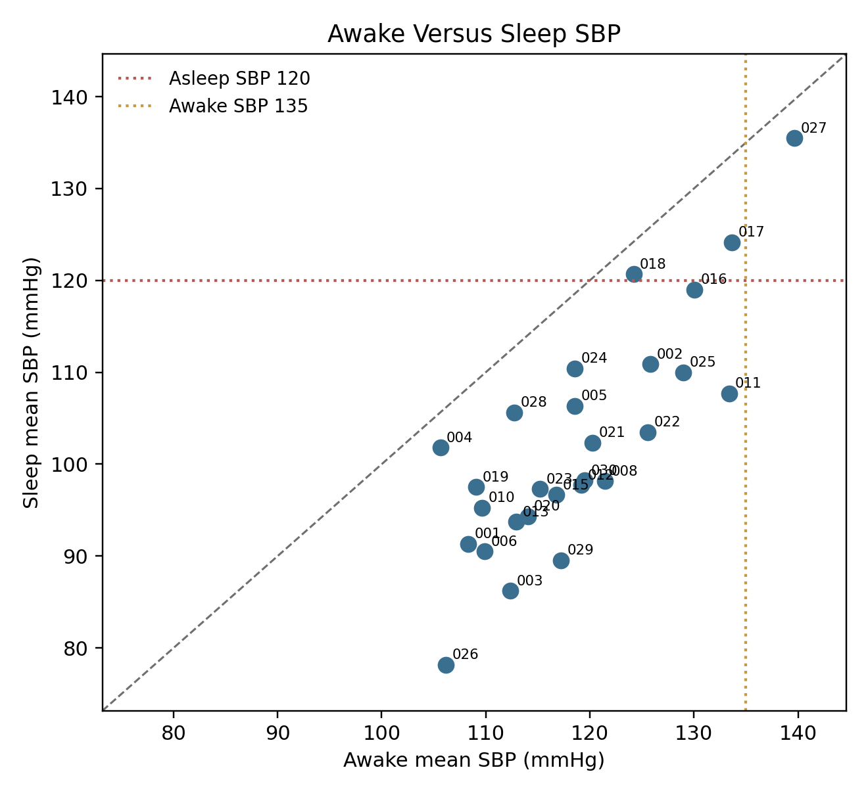

Figure 4. Awake and sleep SBP relationship across participants.
Morning surge varied substantially across participants with adequate sleep data. Because this was a small development dataset, the top-quartile approach was used to flag relatively high surge rather than claiming a universal diagnostic threshold.
Morning surge
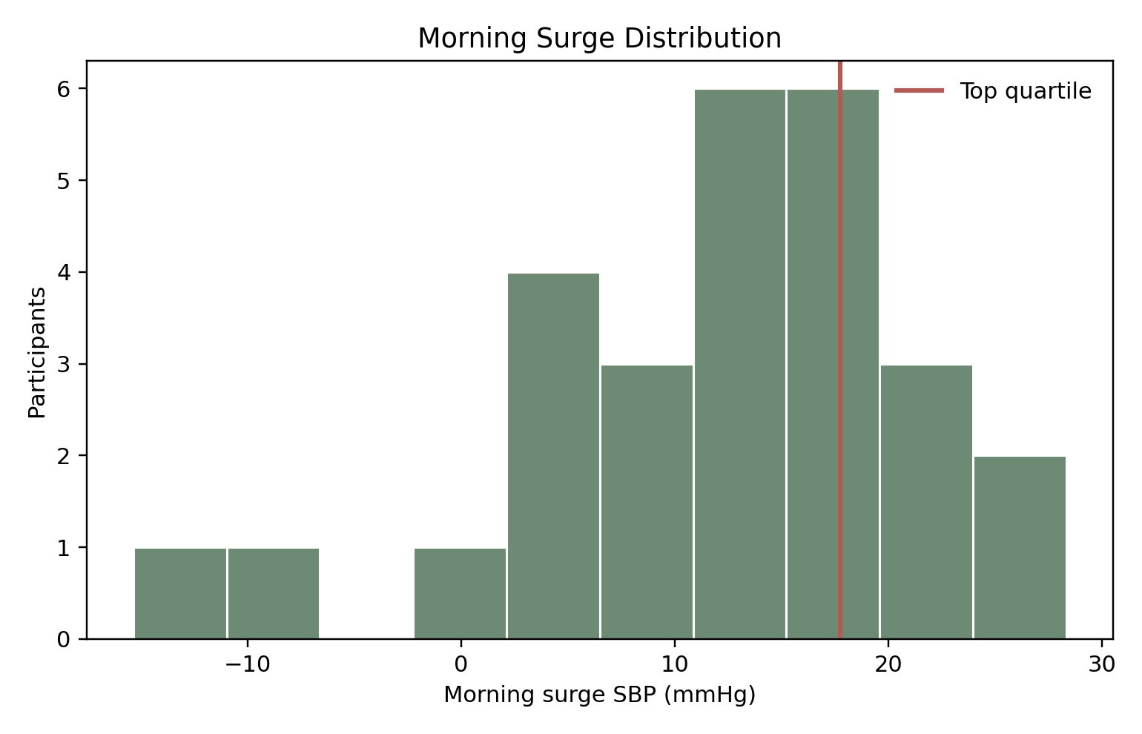

Figure 5. Distribution of morning surge in the primary dataset.
Example 24-hour BP curves demonstrated the clinical purpose of the framework. A raw ABPM curve can show whether BP remains high during sleep, rises after waking, or fluctuates widely across the day. These visual patterns are easier for clinicians and patients to understand than a table of isolated measurements.
Example BP curves
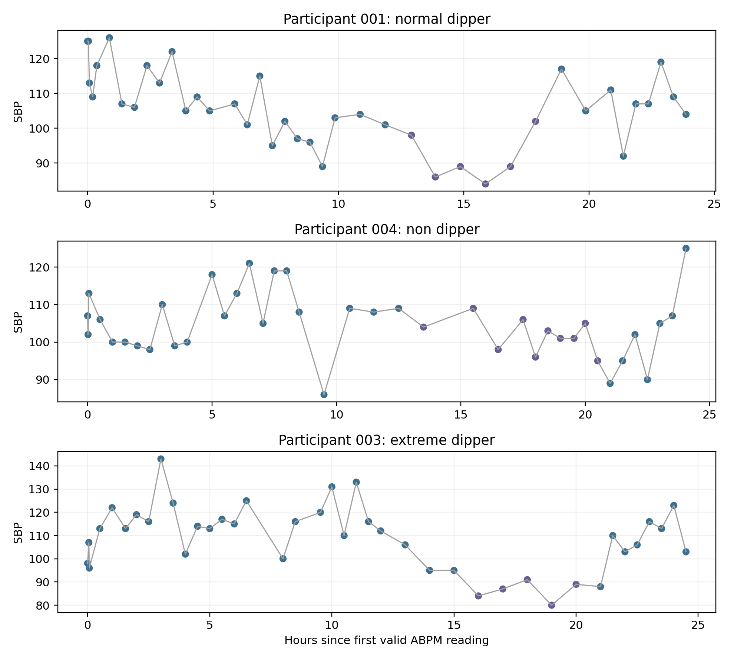

Figure 6. Example sleep-aware BP curves.
Optional physiological streams were available but were not treated as primary outcomes. ABPM exports and Zephyr summaries were present for 30 participants, CGM files for 23 participants, ECG segment files for 29 participants, and BP-merged ECG segment files for 18 participants. These streams support future physiological extensions but were not used to make the main BP claims.
In the Kaggle dataset, label distributions were imbalanced. Morning-Surge was positive in 37 of 270 rows (13.7%), while BP-Variability was positive in all rows and was not modelled as a target. Best cross-validated model performance was strongest for BP load and circadian rhythm. Random forest classified BP-Load with AUROC 0.980, F1-score 0.986, and balanced accuracy 0.976. Random forest classified Circadian-Rythm with AUROC 0.991, F1-score 0.955, and balanced accuracy 0.935. Logistic regression performed best for Morning-Surge with AUROC 0.941, F1-score 0.697, and balanced accuracy 0.874. Logistic regression performed best for Pulse-Pressure with AUROC 0.732, F1-score 0.828, and balanced accuracy 0.737.
Target | Best model | AUROC | F1 | Balanced accuracy
BP-Load | Random forest | 0.980 | 0.986 | 0.976
Circadian-Rythm | Random forest | 0.991 | 0.955 | 0.935
Morning-Surge | Logistic regression | 0.941 | 0.697 | 0.874
Pulse-Pressure | Logistic regression | 0.732 | 0.828 | 0.737

Kaggle feature importance
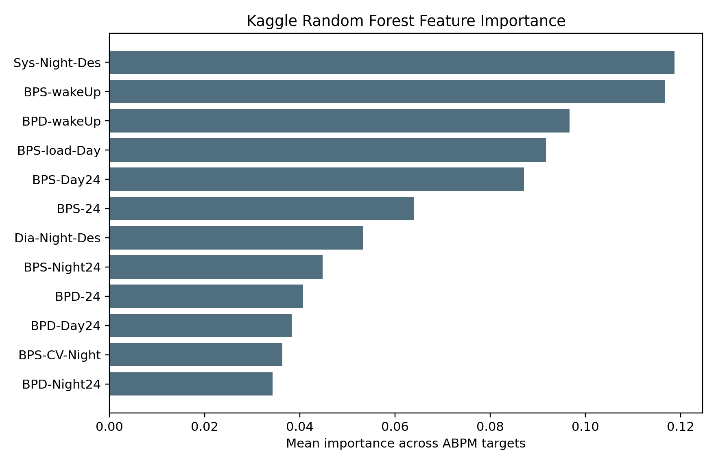

Figure 7. Kaggle feature importance supports the relevance of ABPM-derived feature groups.
For a new patient, the framework produces a rule-based report rather than a model-generated clinical decision. For example, a patient with awake mean SBP 140 mmHg, sleep mean SBP 138 mmHg, dipping percentage 1.4%, morning surge 24 mmHg, and high SBP variability would be reported as "non-dipper with morning surge and high variability." The review point would be to assess night BP, sleep quality, adherence, caffeine or stress triggers, and medication timing with a clinician.
New patient workflow
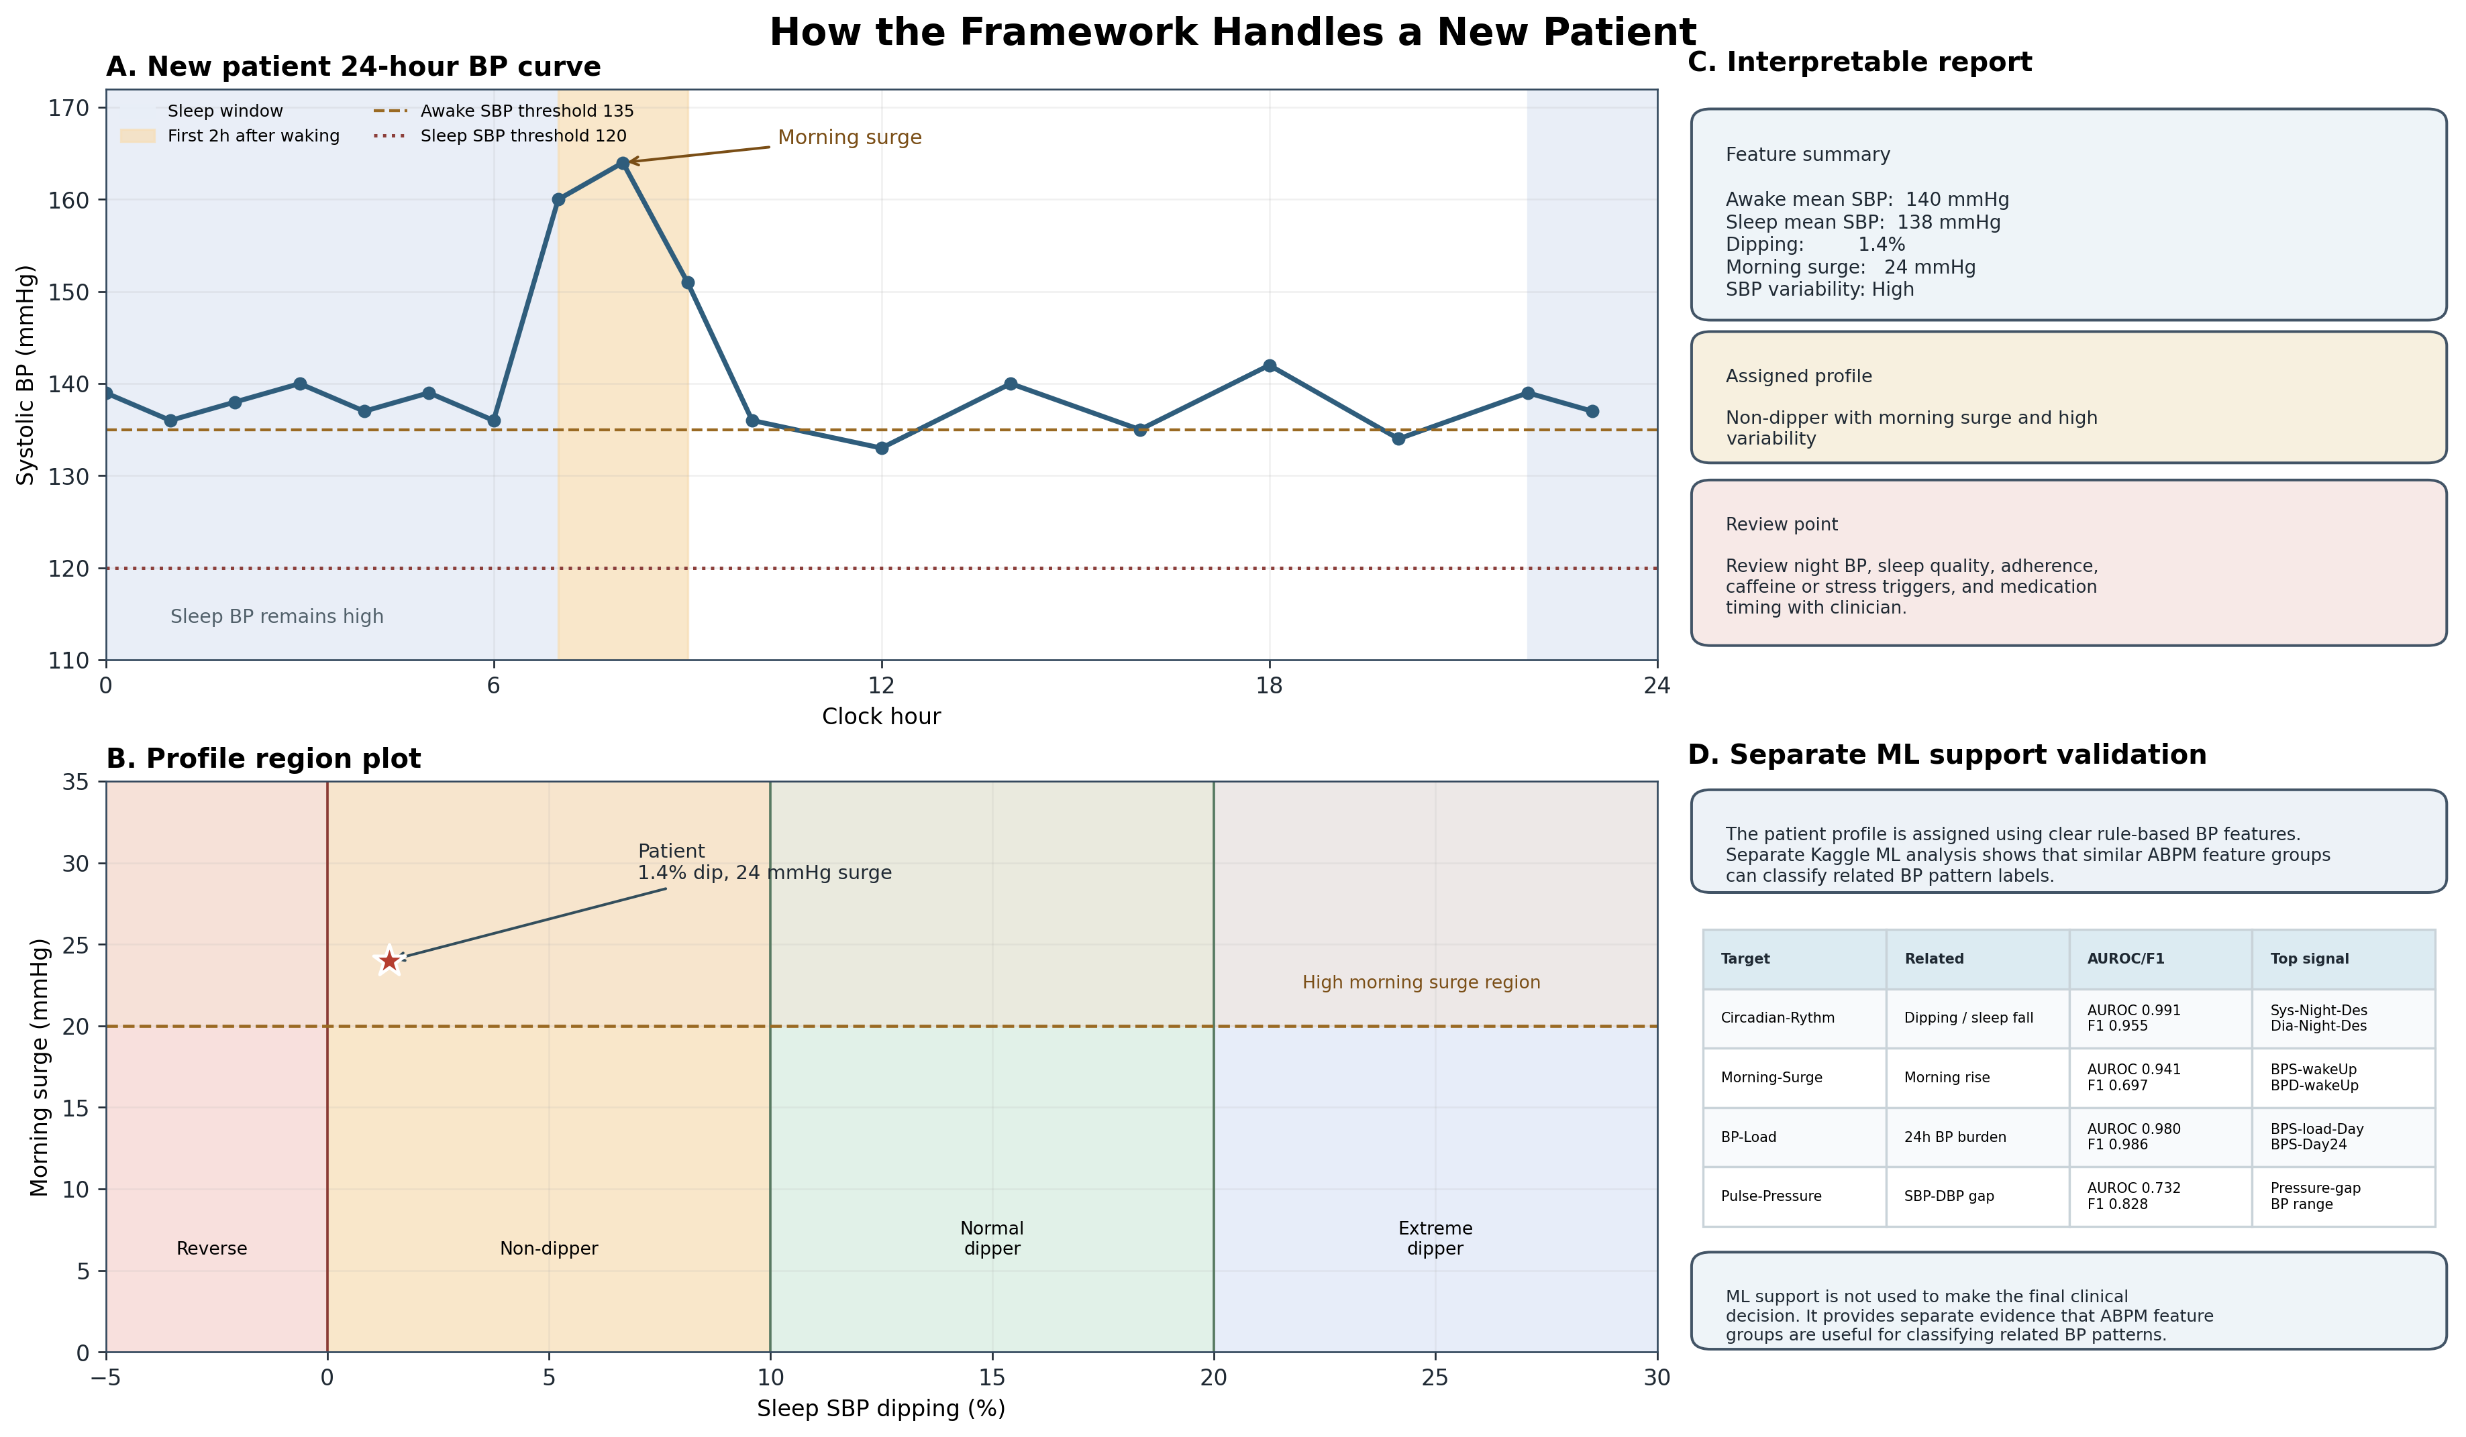

Figure 8. New-patient rule-based reporting with separate ML support validation.

[add]
Gemma-Assisted Explanation — Illustrative Examples
The integrated Gemma 4 assistant was tested with representative queries from both clinical and patient perspectives. Example prompt–response pairs are shown below.
User Query | Gemma Assistant Response (Summary) | Intended User
Why is this patient flagged as high priority? | The report shows blood pressure did not fall during sleep (non-dipper), rose sharply after waking, and varied more than expected across the day. Each of these alone warrants review; together they suggest the pattern should be assessed by the treating doctor before the next routine appointment. | Clinician
What does non-dipper mean? | In most healthy people, blood pressure drops by about 10–20% during sleep, giving the heart and blood vessels a rest overnight. A non-dipper is someone whose blood pressure does not fall enough during sleep. This can put extra strain on the heart and kidneys over time. | Patient
My BP was high all night — is that dangerous? | The report has flagged elevated sleep blood pressure. This is a pattern the doctor should review. Please speak to your treating doctor about this finding at your next visit, or sooner if you have symptoms such as chest pain, headache, or blurred vision. | Patient
Should I take my medication at night instead of morning? | Medication timing decisions should be made by your prescribing doctor, who can weigh all aspects of your health history. Please discuss this with your clinician rather than changing medication timing based on this report alone. | Patient / Clinician

Discussion
This study developed and implemented a sleep-aware ABPM profiling framework that converts raw 24-hour BP readings into clinically interpretable patterns. The main contribution is the combination of transparent rule-based patient profiling, visual report generation, and separate machine-learning support validation. The framework does not attempt to replace clinical judgement. Instead, it organises ABPM information into a format that helps clinicians review the timing and pattern of BP control.
The results align with the broader ABPM literature. Existing guidelines and reviews emphasise that out-of-office BP, particularly night-time BP, adds information beyond clinic BP. Nocturnal hypertension and non-dipping are associated with increased cardiovascular risk, although debate remains about which metric is most prognostically robust. This uncertainty supports our decision to report both sleep BP burden and dipping percentage rather than using dipping alone. Similarly, the morning surge literature recognises potential clinical relevance but also highlights variation in definitions and thresholds. Our framework therefore reports morning surge as a review signal, not as a stand-alone treatment trigger.
The Sri Lankan relevance is practical. A large proportion of adults with hypertension are not adequately controlled, and health services need tools that can improve interpretation without creating unsafe automation. Sri Lanka has specialist clinics where ABPM may be used for selected patients, but it is unlikely to be available for every patient in primary care. A reasonable first use case is therefore targeted: patients with suspected nocturnal hypertension, poor clinic control, morning BP problems, high variability, resistant hypertension, suspected masked hypertension, or medication-timing questions. In these settings, a structured ABPM report can help a clinician decide what to review next.
The Kaggle analysis strengthens the framework but should be interpreted carefully. The high performance for BP-Load and Circadian-Rythm suggests that ABPM-derived summary features contain useful information for classifying abnormal BP patterns. The Morning-Surge result is also encouraging despite label imbalance. However, this is not direct validation of the Dryad participants or a new Sri Lankan patient. It is better understood as dataset-level support: similar ABPM feature groups are meaningful in a separate labelled dataset.
The Gemma integration addresses a different but important problem: interpretability at the point of use. A monitoring system can fail clinically if its output is technically correct but difficult to explain. The assistant allows a doctor or patient to ask questions such as "Why is this patient flagged?", "What does non-dipper mean?", or "What should be reviewed next?" Because the assistant receives only the calculated report summary, it supports explanation rather than independent medical analysis. This design reduces unnecessary data sharing and keeps clinical responsibility with the treating clinician. In future deployments, privacy, local governance, audit logging, and institutional approval would still be required before use with identifiable patient data.
The study has limitations. The primary dataset included only 30 participants, so cohort-relative thresholds for variability and morning surge should not be treated as universal cut-offs. Several participants had insufficient valid sleep BP readings, reinforcing the importance of data-quality reporting. The Dryad and Kaggle datasets came from different cohorts and cannot be row-merged. The machine-learning component validates feature relevance but not patient-level outcomes. The framework has not yet been prospectively validated in Sri Lankan clinical practice, and it does not test whether reporting these profiles improves BP control, medication adherence, cardiovascular outcomes, or hospital admissions.
Future work should include clinician review of the report wording, usability testing with Sri Lankan doctors and nurses, and prospective evaluation in selected hypertension clinics. Expert review should ideally involve a consultant cardiologist, consultant physician, nephrologist, clinical pharmacologist, and ABPM nurse or technician. Once reviewed, the manuscript can state that the clinical wording and monitoring pathway were independently assessed for safety and interpretability. Until then, the appropriate claim is that expert clinical validation is planned.

Add Comparison with Existing Systems (Add to the existing discussion doesn’t need to have a separate section)
Existing commercial ABPM software (e.g., Spacelabs, Meditech) provides 24-hour means, load percentages, and dipping summaries, but these outputs are typically formatted for specialist interpretation and do not include structured monitoring pathways or patient-facing explanatory interfaces. Several academic prototypes have used machine learning for BP pattern classification, but most are trained on proprietary clinical datasets, target invasive waveform reconstruction, or do not include explainability layers [10,11]. The present framework is, to our knowledge, the first to combine transparent rule-based ABPM profiling, open public-data validation, a Sri Lankan clinical context, and an integrated large language model explanation layer.
Add Future Directions (Add to the existing discussion doesn’t need to have a separate section)
Planned future work includes: (1) prospective validation in selected hypertension clinics in Sri Lanka, with expert clinical review of report wording and monitoring pathways; (2) multilingual extension of the Gemma assistant to Sinhala and Tamil; (3) integration of additional physiological streams available in the Dryad dataset (ECG segments, continuous glucose monitoring, Zephyr respiratory data) to extend the framework beyond BP alone; (4) privacy-preserving federated learning to allow model improvement without centralising identifiable data; and (5) a randomised controlled pilot to assess whether structured ABPM reporting improves BP control at six months compared with standard ABPM reporting in a Sri Lankan district-level clinic.

Conclusion
The sleep-aware BP profiling framework converts 24-hour ABPM readings into interpretable circadian BP profiles using transparent clinical rules. In the primary dataset, it identified normal dipping, non-dipping, extreme dipping, high morning surge, high variability, insufficient sleep BP data, and sustained high BP patterns. A separate Kaggle analysis showed that related ABPM feature groups can classify abnormal BP pattern labels, supporting the relevance of the framework without replacing rule-based clinical interpretation. The addition of a Gemma-assisted explanation layer may improve doctor and patient understanding while preserving the safety boundary that medication decisions remain clinician-led. With expert review and prospective validation, this framework could support more personalised hypertension monitoring in Sri Lanka and similar health-system settings.

Data and Code Availability
The analysis code, dashboard prototype, report assistant, paper figures, tables, and manuscript files are available at:
https://github.com/maninka123/personalised-bp-monitoring

Raw datasets are not committed to the repository. The analysis expects the Dryad physiological monitoring dataset and Kaggle ABPM .arff file to be stored locally.

Ethics and Clinical Use Statement
This is a retrospective data-analysis and software-prototype project using public or locally stored research datasets. It is not a medical device and is not approved for independent clinical decision-making. Any clinical use would require local governance review, privacy assessment, expert validation, prospective testing, and appropriate clinical oversight.

References
- World Health Organization. Sri Lanka Hypertension Profile 2023. https://cdn.who.int/media/docs/default-source/country-profiles/hypertension/hypertension-2023/hypertension_lka_2023.pdf
- Rannan-Eliya RP, et al. Hypertension diagnosis, awareness, treatment, and control in Sri Lankan adults: a nationally representative cross-sectional study. BMC Public Health. https://link.springer.com/article/10.1186/s12889-025-22659-7
- European Society of Hypertension. 2023 ESH Guidelines for the management of arterial hypertension. Journal of Hypertension. https://ehrica.org/wp-content/uploads/2024/12/guias-esc-2023-hta.pdf
- American College of Cardiology/American Heart Association. 2017 Guideline for High Blood Pressure in Adults. https://www.acc.org/About-ACC/Press-Releases/2017/11/13/15/35/High-blood-pressure-redefined-for-first-time-in-14-years-130-is-the-new-high
- Salles GF, et al. Non-dipping blood pressure or nocturnal hypertension: does one matter more? Current Hypertension Reports. https://pubmed.ncbi.nlm.nih.gov/37955827/
- Sheppard JP, et al. Prognostic significance of the morning blood pressure surge in clinical practice: a systematic review. American Journal of Hypertension. https://pmc.ncbi.nlm.nih.gov/articles/PMC4261916/
- Project data files analysed by this repository: Blood_Pressure_Sleep_Info.xlsx, Participant_Information.csv, Data_Collection_Notes.csv, and ABPM-dataset.arff.
[Patients Report]
[Doctors app]
[Patients interface so they can be more aware of what is in the report; programmed in a way that it didn’t give medical advice, only suggestions]
[Locally hosted model No privacy concerns; data is secure]

Figure Captions
- fig_1_framework_pipeline.png: Overall sleep-aware BP profiling pipeline from ABPM upload to clinician-review output.
- fig_2_dipping_categories.png: Dryad participant distribution across rule-based dipping categories.
- fig_3_awake_vs_sleep_sbp.png: Participant-level awake and sleep SBP relationship, with ABPM review thresholds.
- fig_4_morning_surge_distribution.png: Distribution of Dryad morning surge values; high surge was cohort-relative top quartile.
- fig_5_example_bp_curves.png: Example SBP curves showing different sleep-aware BP profiles.
- fig_6_kaggle_feature_importance.png: Mean random forest feature importance across Kaggle ABPM classification targets.
- fig_7_clinical_monitoring_pathway.png: Rule-based detected profile and safe monitoring recommendation pathway.
- fig_8_new_patient_rule_based_report_with_ml_support.png: New-patient report workflow with separate Kaggle ML support validation panel.
- fig_9_dataset_complementarity.png: Why Dryad and Kaggle are complementary rather than row-merged datasets.
- fig_10_results_dashboard.png: Main Dryad and Kaggle results summarized in one figure.

